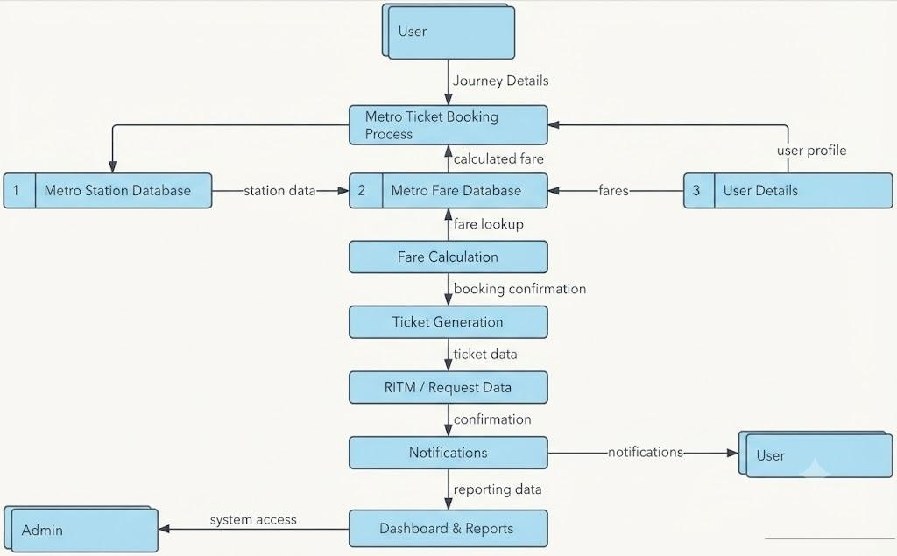
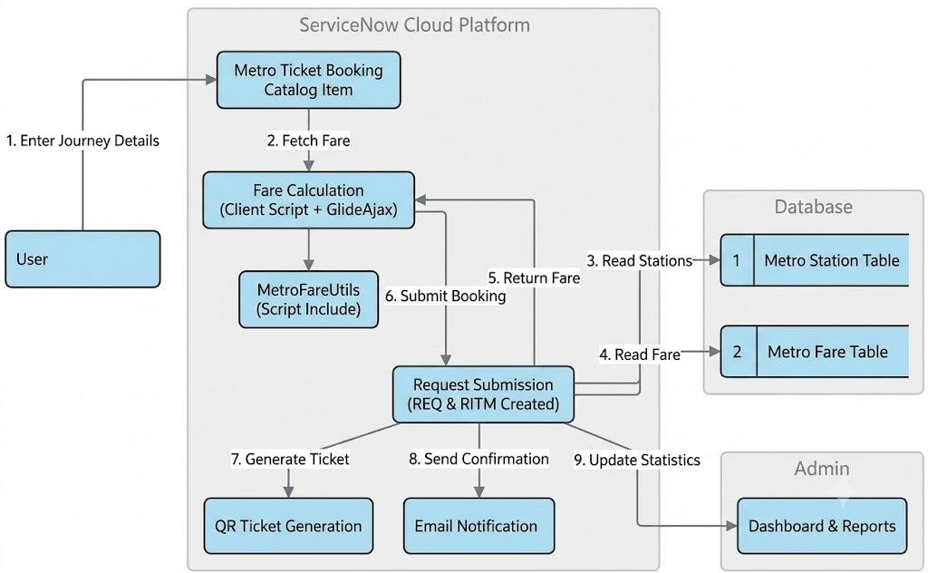
Data Flow Diagrams:

Project Design Phase-II
Data Flow Diagram & User Stories

Date | 25-06-2026
Team ID | 23A51A0215
Project Name | Metro Ticket Generating System in ServiceNow
Maximum Marks | 4 Marks

User Stories
Use the below template to list all the user stories for the product.

User Type | Functional Requirement  (Epic) | User Story Number | User Story / Task | Acceptance Criteria | Priority | Release
Customer (Web  User) | Metro Ticket  Booking | USN-1 | As a user, I can select source and destination  stations for my journey. | User can successfully  select valid stations. | High | Sprint-1
Customer (Web  User) | Metro Ticket  Booking | USN-2 | As a user, I can select a journey date and  number of passengers. | Journey details are  captured successfully. | High | Sprint-1
Customer (Web User) | Fare Calculation | USN-3 | As a user, I can view the fare automatically based on selected stations. | Correct fare is displayed without manual  calculation. | High | Sprint-1
Customer (Web User) | Fare Calculation | USN-4 | As a user, I can view the total fare based on passenger count. | Total fare updates automatically when  passenger count changes. | High | Sprint-1
Customer (Web  User) | Ticket Generation | USN-5 | As a user, I can submit a metro ticket booking  request. | REQ and RITM records are  generated successfully. | High | Sprint-1
Customer (Web  User) | Ticket  Confirmation | USN-6 | As a user, I can view booking confirmation  after submission. | Booking confirmation  message is displayed. | High | Sprint-1
Customer (Web User) | Notification Service | USN-7 | As a user, I can receive a ticket confirmation email after booking. | Confirmation email is received with ticket  details. | Medium | Sprint-2
Customer (Web  User) | QR Ticket  Generation | USN-8 | As a user, I can receive a QR-code-based  digital ticket. | QR code is generated and  linked to the booking. | Medium | Sprint-2
Administrator | Station Management | USN-9 | As an administrator, I can add and manage metro stations. | Station details can be  created, updated, and deleted. | High | Sprint-1
Administrator | Fare  Management | USN-10 | As an administrator, I can maintain fare  information between stations. | Fare records can be added  and updated successfully. | High | Sprint-1
Administrator | Dashboard & Reporting | USN-11 | As an administrator, I can view booking analytics and reports. | Dashboard displays ticket count and booking  statistics. | Medium | Sprint-2

